**A**

***PROJECT REPORT***

*On*

***Definition of a Chatbot (AI)***

*Submitted in partial fulfilment of the requirements for the degree of*

**BACHELOR OF TECHNOLOGY**



Session: - 2024

Submitted by

Varun Ameta (20ETCCS113)

Dev Bikaneria (20ETCCS028)

Under Guidance of

Mr. Aaditya Maheshwari

Assistant Professor

Dept. of CSE TINJRIT, Udaipur

**DEPARTMENT OF COMPUTER SCIENCE AND ENGINEERING**

**TECHNO INDIA NJR INSTITUTE OF TECHNOLOGY, UDAIPUR-313001**

**2024**

**A**

***PROJECT REPORT***

*On*

**Definition of a Chatbot (AI)**

*Submitted in partial fulfilment of the requirements for the degree of*

**BACHELOR OF TECHNOLOGY**



**Session: - 2024**

Submitted by

Varun Ameta(20ETCCS113)

Dev Bikaneria (20ETCCS028)

8th Sem (CSE)

Under Guidance of

Mr. Aaditya Maheshwari

Assistant Professor

Dept. of CSE TINJRIT, Udaipur

**DEPARTMENT OF COMPUTER SCIENCE AND ENGINEERING**

**TECHNO INDIA NJR INSTITUTE OF TECHNOLOGY, UDAIPUR-313001**

**2024**



Department of Computer Science and Engineering Techno India NJR Institute of Technology, Udaipur-313001

# 

# Certificate

This is to certify that project work titled **Definition of a Chabot (AI/ML)** by **Varun Ameta** was successfully carried out in the Department of Computer Science and Engineering, TINJRIT and the report is approved for submission in the partial fulfillment of the requirements for award of degree of Bachelor of Technology in Computer Science and Engineering.

Mr. Aaditya Maheshwari Dr. Rimpy Bishnoi Assistant Professor Head of Department

Dept. of CSE TINJRIT, Udaipur Dept. of CSE TINJRIT, Udaipur

Date Date



Department of Computer Science and Engineering Techno India NJR Institute of Technology, Udaipur-313001

# Certificate

This is to certify that project work titled **Definition of a Chabot (AI/ML)** by **Dev Bikaneria** was successfully carried out in the Department of Computer Science and Engineering, TINJRIT and the report is approved for submission in the partial fulfillment of the requirements for award of degree of Bachelor of Technology in Computer Science and Engineering.

Mr. Aaditya Maheshwari Dr. Rimpy Bishnoi Assistant Professor Head of Department

Dept. of CSE TINJRIT, Udaipur Dept. of CSE TINJRIT Date Date

# Examiner Certificate

This is to certify that the following student **Varun Ameta** and **Dev Bikaneria** of final year B.Tech. (Computer Science and Engineering), was examined for the project work titled **Definition of Chatbot** during the academic year 2023 – 2024 at Techno India NJR Institute of Technology, Udaipur

### Remarks:

**Date:**

Signature Signature

(**Internal Examiner**) (**External Examiner**) Name: - Name: -

Designation: - Designation: -

Department: - Department: -

Organization: - Organization: -

## ACKNOWLEDGMENT

We take this opportunity to record our sincere thanks to all who helped us to successfully complete this work. Firstly, we are grateful to our supervisor **Mr. Aaditya Maheshwari.**

for his invaluable guidance and constant encouragement, support and most importantly for giving us the opportunity to carry out this work.

We would like to express our deepest sense of gratitude and humble regards to us

Head of Department **Dr. Rimpy Bishnoi** for giving invariable encouragement in our endeavors and providing necessary facility for the same. Also, a sincere thanks to all faculty members of CSE, TINJRIT for their help in the project directly or indirectly.

Finally, we would like to thank my friends for their support and discussions that have proved very valuable for us. We are indebted to our parents for providing constant support, love and encouragement. We thank them for the sacrifices they made so that we could grow up in a learning environment. They have always stood by us in everything we have done, providing constant support, encouragement and love.

### Varun Ameta (20ETCSS113)

### Dev Bikaneria (20ETCCS028)

DEPARTMENT OF COMPUTER SCIENCE AND ENGINEERING TECHNO INDIA NJR INSTITUTE OF TECHNOLOGY, UDAIPUR-313001

**CONTENTS**

|  |  |
| --- | --- |
| **Name Of Content** | **Page No.** |
| **Certificates** | **3-5** |
| **Acknowledgements** | **6** |
| **Contents** | **7** |
| **List of Figures** | **8** |
| 1. **Chapter 1: Introduction**    1. **Name of Project**    2. **Problem Statement**    3. **Objective**    4. **Features**    5. **Technologies Used**    6. **Adv. & DisAdv. Of Technologies Used** | **9-16** |
| **2 Chapter 2: Implementation**  **2.1Implementation 2.2Working 2.3Evolution** | **17-21** |
| **Chapter 3: Optimization**   * 1. **Qualitative Analysis**   2. **Quantitative Analysis**   3. **Discuss of result** | **22-25** |
| **Chapter 4: Project Code**   * 1. **Project Code** | **26-30** |
| **Significance** | **31** |
| **Conclusion** | **3** |
| **Advantages & Disadvantages** | **35** |
| **Future Scope** | **37** |
| **Bibliography** | **39** |

**List Of Figures**

|  |  |
| --- | --- |
| **Name Of Figure** | **Page No.** |
| **Fig 1: - Python Logo** | **13** |
| **Fig 2: - OpenAI API** | **13** |
| **Fig 3: - Weather API** | **14** |
| **Fig 4: - Project Output** | **31** |

**Chapter 1: INTRODUCTION**

## Name of Project:

Definition of Chatbot

## Problem Statement:

In the realm of advancing technology, a pioneering project introduces a revolutionary chatbot poised to redefine leisure. By meticulously analysing personal preferences, indoor/outdoor inclinations, location, weather, time, group size, and budget constraints, the chatbot crafts tailored recommendations to enhance user satisfaction. It seamlessly integrates individual interests into its algorithm, presenting a diverse array of activities ranging from cultural pursuits to outdoor adventures. Moreover, the chatbot adapts recommendations to align with the rhythms of the day, ensuring temporal relevance and contextual significance. Logistical considerations, such as group size and budget, are adeptly accounted for, fostering inclusivity and accessibility. Emphasizing variety and novelty, the chatbot refreshes recommendations to prevent monotony, creating a dynamic leisure ecosystem that evolves with user preferences. In essence, this innovative chatbot represents a paradigm shift in leisure, offering a personalized concierge service that transcends traditional boundaries, enriching each leisure moment with joy, fulfilment, and endless exploration.

## Objective of this Project:

### Personalization:

* Develop algorithms to analyse and understand individual preferences.
* Incorporate user feedback mechanisms to continuously refine recommendations.
* Implement machine learning techniques to adapt to evolving user preferences over time.

### Integration of Variables:

* Utilize data on indoor/outdoor inclinations, location, weather, time of day, and group size to generate personalized suggestions.
* Develop a comprehensive database of leisure activities and venues to draw
* Integrate real-time data sources to ensure accuracy and relevance of suggestions.

### Optimization for User Experience:

* Design an intuitive and user-friendly interface for seamless interaction with the chatbot.
* Implement natural language processing capabilities to facilitate smooth communication and understanding of user inputs.
* Prioritize speed and efficiency in delivering recommendations to enhance user engagement.

### Adaptability and Dynamism:

* Develop algorithms to prevent repetition and maintain variety in suggested activities.
* Incorporate features to accommodate changes in user preferences, seasonal variations, and emerging leisure trends.
* Enable the chatbot to adjust recommendations based on user feedback and changing external factors.

### Inclusivity and Accessibility:

* Ensure recommendations cater to diverse interests, age groups, and cultural backgrounds.
* Provide options for activities that suit different budget constraints and accessibility requirements.
* Implement multi-lingual support to make the chatbot accessible to a wider audience.

### Continuous Improvement:

* Establish mechanisms for ongoing evaluation and optimization of the chatbot's performance.
* Conduct user surveys, usability testing, and data analysis to identify areas for enhancement.
* Collaborate with leisure industry experts and stakeholders to incorporate new features and improve recommendation accuracy.

## Features:

### Personalization

* + **User Preferences:** The chatbot engages users in meaningful conversations to gather insights into their hobbies, interests, and past activities. This active analysis aims to create a nuanced understanding of individual preferences, ensuring that suggestions align with the user's unique tastes.
  + **Indoor/Outdoor Selection:** Recognizing diverse user inclinations, the chatbot allows users to express their preference for indoor or outdoor activities. This critical feature enables the chatbot to tailor recommendations, ensuring alignment with the user's desired environmental setting for a more enjoyable and personalized experience.

### Location and Weather Integration

* + **Current Location:** Leveraging geolocation data, the chatbot optimizes suggestions by recommending activities feasible within the user's current vicinity. This context-driven approach enhances the relevance of recommendations and increases user engagement.
  + **Weather Conditions:** Real-time weather data integration is crucial, allowing the chatbot to factor in current weather conditions when proposing activities. Considering elements such as temperature, precipitation, and overall climate ensures suggestions are not only tailored to user preferences but also suitable for prevailing weather, enhancing the overall user experience.

### Time and Participants

* + **Time of Day:** Recognizing varying moods and preferences throughout the day, the chatbot takes into account the time of day when suggesting activities. Whether morning, afternoon, evening, or night, recommendations are tailored to match the temporal context, ensuring resonance with the user's current mindset.
  + **Number of Participants:** Acknowledging the social dynamics of leisure activities, users can specify the number of participants involved. This feature allows the chatbot to suggest activities suitable for solo endeavours, group outings, or family engagements, catering to diverse user preferences and social contexts.

### Budget Considerations

* + **Budget Constraints:** Understanding the significance of financial considerations in activity choices, the chatbot empowers users by allowing them to set budget limits. Incorporating this feature ensures that suggestions align with the user's financial constraints, promoting accessibility and enhancing the overall user experience.

### Activity History

* + **Previous Activities:** To add an element of novelty to each user interaction, the chatbot meticulously tracks the user's activity history. By keeping a record of past activities, the chatbot ensures that suggestions are unique and not repeated more than three times. This preventative measure against monotony aims to keep the user engaged by offering a continuous stream of fresh and unexplored leisure options.

### Emotional Well-being

* + **User Happiness:** At the heart of the chatbot's mission is the commitment to contribute positively to the user's emotional well-being. By curating suggestions aligned with individual preferences, the chatbot seeks to create experiences actively contributing to the user's happiness and overall satisfaction. This user-centric approach underscores the chatbot's role as not merely a boredom alleviator but as a genuine companion in the pursuit of a fulfilling lifestyle.

In essence, each feature of the chatbot is meticulously crafted to provide a comprehensive and user- centric leisure experience. By combining personalization, location awareness, temporal sensitivity, budget considerations, historical tracking, and a focus on emotional well-being, the chatbot aspires to be a versatile and indispensable tool in enhancing users' leisure time. Through dynamic and engaging activity suggestions, the chatbot aims not only to combat boredom but also to actively contribute to the enhancement of users' happiness and overall quality of life.

## Technologies Used: -

### Python:



Fig 1: - Python Logo

* + Versatile Programming Language: Python's flexibility and extensive library support facilitated the development of various components within the chatbot application.
  + Efficient Data Processing: Python's rich ecosystem of data processing libraries enabled efficient handling and manipulation of user data, enhancing the overall performance of the chatbot.
  + Scalable Application Development: Python's readability and ease of maintenance contributed to the creation of scalable and maintainable codebase, facilitating future updates and enhancements.
  + Extensive Community Support: Python's large and active community provided access to resources, documentation, and support, streamlining the development process and troubleshooting efforts.

### OpenAI API:

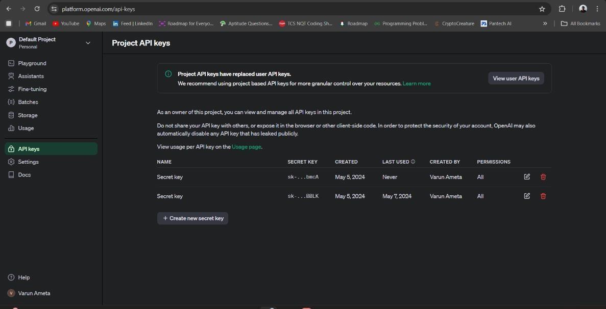

Fig 2: - OpenAI API

* + Advanced Natural Language Processing: The OpenAI API provided access to state-of-the- art language models, enabling the chatbot to understand user queries, generate coherent responses, and deliver personalized recommendations.
  + Seamless Integration: The API's user-friendly interface and comprehensive documentation simplified the integration process, allowing for quick implementation of advanced NLP capabilities within the chatbot application.
  + Continuous Improvement: OpenAI's commitment to research and development ensured access to cutting-edge advancements in NLP technology, enabling the chatbot to evolve and adapt to changing user needs and preferences.
  + Privacy and Security: OpenAI's robust security measures and privacy policies ensured the confidentiality and protection of user data, instilling trust and confidence in the chatbot's users.

### Weather API:

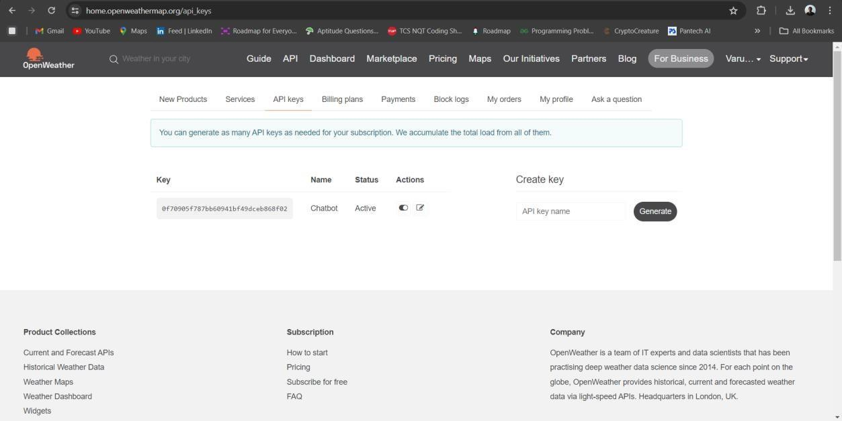

Fig 3: - Weather API

* + Real-time Weather Data Retrieval: Integration with a weather API enabled the chatbot to retrieve up-to-date weather information based on user location, enhancing the relevance and accuracy of leisure recommendations.
  + Contextualized Recommendations: Utilizing weather data allowed the chatbot to tailor recommendations according to current weather conditions, suggesting outdoor activities on sunny days and indoor alternatives during rain or extreme temperatures.
  + Location-Based Personalization: By leveraging weather data in conjunction with user location, the chatbot provided location-specific recommendations, ensuring that leisure activities were suitable for the user's geographical area.
  + Adaptive Response Generation: Incorporating weather information into response generation algorithms enabled the chatbot to dynamically adjust recommendations in real-time, providing users with timely and contextually appropriate suggestions.

## Advantages and Disadvantages of Technologies Used: -

### Python:

**Advantages:**

* + Readability and Maintainability: Python's clean and concise syntax promotes readability, making it easier for developers to write and understand code. This enhances maintainability and facilitates collaboration among team members.
  + Extensive Library Support: Python boasts a vast ecosystem of libraries and frameworks for various tasks, such as data processing, web development, and machine learning. This extensive library support accelerates development and enables developers to leverage pre- existing solutions.
  + Platform Independence: Python is platform-independent, meaning code written in Python can run on different operating systems without modification. This enhances portability and facilitates deployment across diverse environments.
  + Rapid Prototyping: Python's dynamic nature and interpreted execution allow for rapid prototyping and iterative development cycles, enabling developers to quickly experiment with ideas and iterate on solutions.

### Disadvantages:

* + Performance Limitations: Python's interpreted nature can result in slower execution speeds compared to compiled languages like C or C++. This performance overhead may be significant for computationally intensive tasks or real-time applications.
  + Global Interpreter Lock (GIL): Python's Global Interpreter Lock (GIL) can limit concurrency in multi-threaded applications, potentially hindering performance in scenarios requiring parallelism or concurrency.
  + Dependency Management Challenges: Python's dependency management can be challenging, particularly in projects with complex dependencies or conflicting package versions. Dependency resolution issues may arise, leading to compatibility issues or dependency conflicts.
  + Lack of Static Typing: Python's dynamic typing can lead to potential errors and bugs that may only manifest at runtime. The absence of static typing can make it more challenging to detect and prevent certain types of errors during development.

### OpenAI API:

**Advantages:**

* + Advanced NLP Capabilities: The OpenAI API provides access to advanced natural language processing (NLP) models, such as GPT (Generative Pre-trained Transformer), capable of understanding and generating human-like text. This enables developers to build sophisticated language-based applications without extensive expertise in NLP.
  + Scalability and Performance: Leveraging OpenAI's cloud-based infrastructure, the API offers scalability and high-performance computing capabilities, allowing developers to process large volumes of text data and generate responses quickly and efficiently.
  + Continuous Improvement: OpenAI invests in ongoing research and development, continuously improving its NLP models and releasing updates to the API. This ensures access to state-of-the-art NLP technology and enables applications to evolve alongside advancements in the field.
  + Accessibility and Ease of Use: The OpenAI API is designed to be user-friendly, with comprehensive documentation, developer resources, and support. This accessibility lowers the barrier to entry for developers looking to incorporate advanced NLP capabilities into their applications.

### Disadvantages:

* + Cost Considerations: While OpenAI offers free access to its API for limited usage, developers may incur costs for higher volumes of usage or access to premium features. Cost considerations should be taken into account when scaling applications using the OpenAI API.
  + Dependency on External Service: Applications relying on the OpenAI API are dependent on external service availability and performance. Service disruptions or downtime from OpenAI could impact application functionality and user experience.
  + Privacy and Security Concerns: Utilizing the OpenAI API involves sharing text data with a third-party service provider, raising privacy and security concerns. Developers must ensure compliance with privacy regulations and implement appropriate safeguards to protect user data.
  + Model Bias and Ethical Considerations: Like all AI models, OpenAI's models may exhibit biases or generate inappropriate content. Developers must be mindful of ethical considerations and implement measures to mitigate bias and ensure responsible use of AI technology.

### Weather API:

**Advantages:**

* + Real-Time Weather Data: Weather APIs provide access to up-to-date weather information, including temperature, precipitation, wind speed, and humidity. This real-time data enables applications to deliver accurate and timely weather forecasts to users.
  + Location-Based Forecasting: Weather APIs offer location-based forecasting, allowing applications to retrieve weather data specific to the user's geographical location. This enables personalized recommendations and ensures that weather-related information is relevant to the user's context.
  + Integration Flexibility: Weather APIs are designed to be easily integrated into applications, with developer-friendly documentation, RESTful endpoints, and SDKs available for various programming languages. This flexibility streamlines the integration process and accelerates development.
  + Enhanced User Experience: By incorporating weather data into applications, developers can enhance the user experience by providing contextual information and tailored recommendations. Weather-aware features such as clothing suggestions, event planning, and travel advisories can improve user engagement and satisfaction.

### Disadvantages:

* + Reliance on External Service: Applications utilizing weather APIs are dependent on external weather service providers for data availability and accuracy. Service disruptions, downtime, or changes to the API's terms of use could impact application functionality.
  + Data Limitations and Accuracy: Weather APIs may have limitations in terms of data granularity, coverage, and accuracy. Developers should carefully evaluate the quality and reliability of weather data provided by the API and consider supplementing it with additional sources if necessary.
  + Cost Considerations: While some weather APIs offer free access to basic weather data, premium features or higher usage volumes may incur costs. Developers should consider the pricing model of the weather API and assess the long-term financial implications for their application.
  + Privacy and Security: Weather APIs involve sharing location information with third-party service providers, raising privacy and security concerns. Developers must ensure compliance with privacy regulations and implement measures to protect user data from unauthorized access or misuse.

**Chapter 2: Implementation**

# Implementation Overview

The implementation of the leisure recommendation chatbot entails a detailed process involving data preprocessing, integration of APIs, and meticulous user interface design. Here's a comprehensive breakdown of the implementation steps:

### Data Preprocessing:

* + Gather user data through input forms or registration processes, capturing information such as leisure preferences, location, preferred activities, and any constraints like budget or group size.
  + Clean and sanitize the collected data to ensure consistency and remove any inconsistencies or errors.
  + Organize the pre-processed data into a structured format that can be easily accessed and utilized by the chatbot algorithms.

### Integration of APIs:

* + Integrate the OpenAI API into the chatbot backend to enable natural language processing (NLP) capabilities. This involves setting up authentication, making API requests, and handling responses.
  + Incorporate a weather API to fetch real-time weather data based on the user's location. This data will be used to adjust leisure recommendations according to current weather conditions.
  + Develop error handling mechanisms to gracefully manage API failures or unexpected responses, ensuring a seamless user experience.

### User Interface Design:

* + Design a user-friendly interface for the chatbot, considering factors such as simplicity, intuitiveness, and accessibility.
  + Implement input mechanisms to capture user queries and preferences, such as text input fields, dropdown menus, or interactive buttons.
  + Develop conversational flows and dialogue prompts to guide users through the interaction process and elicit necessary information.
  + Display personalized leisure recommendations to the user in a visually appealing and informative manner, presenting details such as activity descriptions, locations, and weather forecasts.
  + Optimize the user interface for different devices and screen sizes, ensuring compatibility across desktops, tablets, and mobile devices.

### Testing and Iteration:

* + Conduct comprehensive testing of the chatbot application across different scenarios and use cases, including various user inputs, edge cases, and error conditions.
  + Utilize testing frameworks and tools to automate testing processes and identify potential issues or bugs.
  + Gather feedback from users through usability testing, surveys, and user interviews to assess the effectiveness and user satisfaction of the chatbot.
  + Iterate on the implementation based on user feedback and testing results, making improvements to functionality, user interface design, and overall user experience.
  + By meticulously following these implementation steps, the leisure recommendation chatbot can be developed and refined to provide users with personalized and contextually relevant leisure suggestions, enhancing their overall satisfaction and enjoyment of leisure activities.

## Working: -

The working of the project involves a series of steps to provide personalized leisure recommendations based on user input and contextual factors such as location and weather conditions:

### Initialization:

* + The program initializes by displaying a series of predefined questions to the user, creating an interactive dialogue aimed at understanding the user's preferences and circumstances.
  + Each question is designed to elicit specific information, ranging from the user's boredom level to their location and preferred activities.

### User Input:

* + The user responds to each question posed by the program, providing detailed answers based on their preferences, location, and current situation.
  + Responses are entered through text input fields or selected from predefined options presented by the program.

### Processing User Responses:

* + The program processes the user's responses, extracting relevant information and storing it for further analysis and recommendation generation.
  + Responses undergo validation and sanitization to ensure data integrity and accuracy, addressing potential inconsistencies or errors.

### Location-Based Weather Data Retrieval:

* + Upon receiving the user's location information, the program sends a request to an external weather API to retrieve real-time weather data for that location.
  + The weather API responds with data such as current temperature, humidity, wind speed, precipitation forecast, and general weather conditions.

### Integration with OpenAI API:

* + Concurrently, the program integrates with the OpenAI API, leveraging its advanced natural language processing capabilities to generate personalized leisure recommendations.
  + Using the gathered user responses and weather data, the program constructs a query to the OpenAI API, encapsulating the user's preferences, location, and current weather conditions.

### Leisure Recommendation Generation:

* + The OpenAI API processes the formulated query, employing its language models to generate tailored leisure recommendations specific to the user's preferences and circumstances.
  + Recommendations encompass a wide range of activities, including indoor and outdoor options, cultural experiences, recreational pursuits, and more.
  + The recommendations are dynamically generated based on factors such as the user's interests, location-based weather conditions, time of day, and group size.

### Presentation of Recommendations:

* + The program presents the generated leisure recommendations to the user in a structured and informative format, facilitating easy comprehension and decision-making.
  + Recommendations are displayed along with relevant details such as activity descriptions, locations, time suggestions, and weather forecasts.
  + Users are provided with options to explore additional recommendations, refine their preferences, or seek further information from the chatbot.

### User Interaction and Feedback:

* + Users engage in interactive dialogue with the chatbot, asking questions, seeking clarification, or expressing preferences for specific activities.
  + The chatbot dynamically responds to user interactions, adapting its recommendations or providing additional information as needed.
  + Users have the opportunity to provide feedback on the recommendations received, allowing the chatbot to iteratively improve its suggestions over time based on user input.

Through this detailed process, the project seamlessly integrates user input, location-based weather data, and advanced natural language processing capabilities to deliver highly personalized and contextually relevant leisure recommendations, tailored to each user's preferences and real-time circumstances.

## Evaluation:

### Evaluation Methodology:

* + Describe the methods used to evaluate the performance and effectiveness of the leisure recommendation chatbot.
  + Explain the criteria used to assess various aspects of the chatbot, such as recommendation accuracy, user satisfaction, response time, and usability.

### Data Collection:

* + Detail the process of collecting data for evaluation, including user feedback, survey responses, and interaction logs.
  + Specify the sample size, demographics, and any other relevant characteristics of the users involved in the evaluation process.

### Metrics and Measures:

* + Define the metrics and measures used to quantitatively and qualitatively evaluate the chatbot's performance.
  + Include both objective measures, such as recommendation accuracy and response time, and subjective measures, such as user satisfaction ratings and perceived usefulness.

### Quantitative Analysis:

* + Present the quantitative analysis of the chatbot's performance based on the predefined metrics.
  + Provide numerical results and statistical analysis to demonstrate the chatbot's effectiveness in generating accurate recommendations, responding promptly to user queries, and meeting user expectations.

### Qualitative Analysis:

* + Conduct a qualitative analysis of user feedback and survey responses to assess the chatbot's usability, user experience, and overall satisfaction.
  + Identify common themes, patterns, and sentiments expressed by users regarding their interactions with the chatbot.

### User Satisfaction:

* + Report on user satisfaction levels obtained through surveys or feedback forms, summarizing overall satisfaction ratings and any recurring themes or comments.
  + Discuss factors that contributed to user satisfaction or dissatisfaction, such as the relevance of recommendations, ease of use, and responsiveness of the chatbot.

### Comparison with Baseline:

* + Compare the performance of the leisure recommendation chatbot with baseline or benchmark systems, if applicable.
  + Highlight any improvements or advantages achieved by the chatbot over existing solutions in terms of recommendation accuracy, user engagement, or other relevant metrics.

### Discussion of Results:

* + Interpret the evaluation results in the context of the project objectives and user requirements.
  + Discuss the implications of the findings, identifying strengths, weaknesses, and areas for improvement in the chatbot's design and functionality.

### Limitations and Challenges:

* + Acknowledge any limitations or challenges encountered during the evaluation process, such as data biases, sample size constraints, or technical issues.
  + Consider how these limitations may have influenced the interpretation of the results and suggest avenues for addressing them in future evaluations.

### Future Directions:

* + Propose potential enhancements or extensions to the chatbot based on the evaluation findings and user feedback.
  + Outline future research directions or areas of improvement to further enhance the chatbot's performance, usability, and user satisfaction.

By providing a detailed evaluation and analysis of the chatbot's performance and user feedback, you can offer valuable insights into its effectiveness, strengths, and areas for improvement, informing future development efforts and ensuring the delivery of a high-quality user experience.

**Chapter 3: Optimization**

## Qualitativ*e* Analysis:

### User Feedback Analysis:

* + Analyse user feedback obtained through surveys, interviews, or direct interactions with the chatbot.
  + Categorize feedback based on recurring themes, sentiments, and user perceptions.
  + Identify common positive aspects, such as helpful recommendations, ease of use, and friendly interactions, as well as negative aspects, such as confusion, frustration, or dissatisfaction.

### Usability Evaluation:

* + Evaluate the chatbot's usability based on user interactions and feedback.
  + Assess the clarity of dialogue prompts, ease of navigation, and intuitiveness of the user interface.
  + Identify any usability issues or pain points reported by users, such as unclear instructions, unresponsive buttons, or navigation difficulties.

### User Satisfaction Assessment:

* + Gauge overall user satisfaction with the chatbot's performance and recommendations.
  + Summarize satisfaction ratings obtained from user surveys or feedback forms, categorizing responses into satisfied, neutral, or dissatisfied.
  + Analyse qualitative comments to understand the factors contributing to user satisfaction or dissatisfaction, such as the relevance of recommendations, responsiveness, and overall user experience.

### Sentiment Analysis:

* + Perform sentiment analysis on user feedback to quantify positive and negative sentiments expressed by users.
  + Use natural language processing techniques to analyse the sentiment polarity of user comments, categorizing them as positive, negative, or neutral.
  + Visualize sentiment trends over time or across different user demographics to identify patterns and areas for improvement.

## Quantitative Analysis:

### Recommendation Accuracy:

* + Measure the accuracy of leisure recommendations provided by the chatbot.
  + Define metrics for evaluating recommendation relevance, such as the percentage of recommendations aligned with user preferences or rated positively by users.
  + Calculate recommendation accuracy based on user feedback or objective criteria, comparing recommended activities with user preferences and assessing their relevance.

### Response Time:

* + Evaluate the chatbot's responsiveness by measuring response time for user queries and interactions.
  + Record the time taken for the chatbot to process user inputs, generate recommendations, and deliver responses.
  + Analyse response time metrics to identify bottlenecks or delays in the chatbot's performance and optimize for faster interactions.

### Engagement Metrics:

* + Track user engagement metrics, such as the number of interactions, session duration, and repeat visits.
  + Monitor user engagement patterns over time to assess the chatbot's ability to retain users and encourage continued interaction.
  + Analyse engagement metrics to identify trends, user preferences, and opportunities for enhancing user engagement and retention.

### User Interaction Patterns:

* + Analyse user interaction logs to identify common interaction patterns and user behaviours.
  + Study the frequency and sequence of user actions, such as querying for recommendations, refining preferences, or asking for additional information.
  + Identify popular features, user preferences, and areas of interest based on interaction patterns, informing future development and customization efforts.

### Usability Metrics:

* + Assess usability metrics such as completion rates, task success rates, and error rates to evaluate the efficiency and effectiveness of user interactions.
  + Measure the percentage of users who successfully complete tasks, such as finding relevant recommendations or navigating through the chatbot interface without errors.
  + Identify usability issues and areas for improvement based on usability metrics, prioritizing enhancements to streamline user interactions and improve task completion rates.

By conducting both qualitative and quantitative analyses, you can gain comprehensive insights into the chatbot's performance, usability, and user satisfaction, enabling you to make informed decisions for further refinement and optimization.

## Discussion of result:

### Summary of Findings:

* + Provide a brief summary of the key findings and outcomes of the evaluation, highlighting both qualitative and quantitative results.
  + Summarize the performance of the chatbot in terms of recommendation accuracy, user satisfaction, response time, usability, and engagement metrics.

### Interpretation of Results:

* + Interpret the findings in the context of the project objectives and user requirements.
  + Discuss the implications of the results on the effectiveness and usability of the chatbot, considering both positive aspects and areas for improvement.

### Recommendation Accuracy:

* + Discuss the accuracy of leisure recommendations provided by the chatbot, considering factors such as relevance to user preferences, alignment with user feedback, and consistency over time.
  + Analyse any discrepancies between recommended activities and user expectations, identifying potential reasons and strategies for improvement.

### User Satisfaction:

* + Interpret user satisfaction ratings and feedback obtained from surveys, interviews, or direct interactions with the chatbot.
  + Discuss the factors that contributed to user satisfaction or dissatisfaction, including the quality of recommendations, ease of use, responsiveness, and overall user experience.

### Usability and Engagement:

* + Analyse usability metrics and engagement patterns to assess the effectiveness of the chatbot's design and functionality.
  + Discuss usability issues or challenges identified during the evaluation process and propose recommendations for enhancing usability and user engagement.

### Comparison with Expectations:

* + Compare the actual performance of the chatbot with the expected outcomes and goals defined at the outset of the project.
  + Identify any discrepancies or areas where the chatbot exceeded or fell short of expectations, discussing the implications for future development and refinement.

### Limitations and Challenges:

* + Acknowledge any limitations or challenges encountered during the evaluation process, such as data biases, sample size constraints, or technical issues.
  + Discuss how these limitations may have influenced the interpretation of results and propose strategies for addressing them in future iterations.

### Future Directions:

* + Propose potential enhancements or extensions to the chatbot based on the evaluation findings and user feedback.
  + Outline future research directions or areas of improvement to further enhance the chatbot's performance, usability, and user satisfaction.

### Conclusion:

Summarize the main insights and conclusions drawn from the discussion of results.

Reiterate the significance of the findings in relation to the project objectives and user needs, emphasizing the importance of continuous improvement and iteration.

By engaging in a thorough discussion of the evaluation results, you can provide valuable insights into the performance, usability, and user satisfaction of the chatbot, informing future development efforts and ensuring the delivery of a high-quality user experience.

**chapter 4: Project Code**

# Project Code:

import openai import requests import datetime

from secreatkey import openapi_key, weather_api_key

openai.api_key = openapi_key weather_api_key=weather_api_key

# Create a dictionary to store chat histories for each email email_chat_histories = {}

# Create a dictionary to store suggestions count for each email email_suggestions_count = {}

# Function to display weather information

def display_weather_info(city, temperature, description, time): print(f'Weather information for {city} as of {time}:') print(f'Temperature: {temperature} K')

print(f'Condition: {description.capitalize()}')

def city(location): city = location

get_weather_data(city)

# Replace with your OpenWeatherMap API key api_key = weather_api_key

# Global variables temperature = None description = None time = None

# Function to get weather data from OpenWeatherMap API def get_weather_data(city):

global temperature, description, time # Access the global variables

base_url = [f'http://api.openweathermap.org/data/2.5/weather?q=](http://api.openweathermap.org/data/2.5/weather?q){city}&appid={api_key}' response = requests.get(base_url)

data = response.json()

# Assign values to the global variables temperature = data['main']['temp'] description = data['weather'][0]['description']

time = datetime.datetime.now().strftime('%Y-%m-%d %H:%M:%S') return data

def generate_response(chat_history, user_input):

# Combine the chat history with the user's new input new_message = {"role": "user", "content": user_input} chat_history.append(new_message)

# Generate a response based on the updated chat history response = openai.chat.completions.create(

model="gpt-3.5-turbo", messages=chat_history, max_tokens=250, stop=None

)

# Extract and return the chatbot's response bot_response = response.choices[0].message.content return bot_response

def main():

global email_chat_histories, email_suggestions_count # Access the global dictionaries print("Chatbot: Hello! I'm here to suggest activities when you're bored.")

while True:

# Get the user's email (you can change this to get it from user input)

email = input('Chatbot: Please provide your Email I\'d (type "exit" to quit):\nYou: ') if email == "exit":

break

# Initialize a chat history for the email if not already exists if email not in email_chat_histories:

email_chat_histories[email] = []

chat_history = email_chat_histories[email] # Get the chat history

# Initialize the suggestions count for the email if not already exists if email not in email_suggestions_count:

email_suggestions_count[email] = 0

# Reset the suggestions count if it exceeds 3 if email_suggestions_count[email] >= 3:

email_suggestions_count[email] = 0

print("Chatbot: You've received the maximum number of suggestions (3 times).")

# Define a list of questions to ask the user questions = [

"Are you bored?",

"What is your good name?",

"What do you love to do in your free time?", "Do you prefer indoor or outdoor activities?", "Where are you from?",

"How many people are with you currently?",

]

user_responses = [] # Initialize a list to store user responses for question in questions:

user_response = input(f'Chatbot: {question}\nYou: ') chat_history.append({"role": "user", "content": user_response}) user_responses.append(user_response)

# Stop if the user responds "No" to the first question

if question == "Are you bored?" and user_response.lower() == "no": print("Chatbot: Okay, have a great day!")

return

# Suggest an activity based on the user's responses to the questions suggest_activity(chat_history, user_responses, email)

# Global Variable location = None

def suggest_activity(chat_history, user_responses, email):

# Customize the activity suggestion based on the user's responses to the predefined questions boredom = user_responses[0].lower()

name = user_responses[1].lower() free_time_activity = user_responses[2].lower() indoor_or_outdoor = user_responses[3].lower() location = user_responses[4].lower() people_with_you = user_responses[5].lower() weather_details = get_weather_data(location)

# Check if the user has already received 3 suggestions if email_suggestions_count[email] < 3:

print("Chatbot: Searching for activity suggestions...")

suggestion = generate_suggestion(boredom, name, free_time_activity, weather_details, indoor_or_outdoor, location, people_with_you)

print(f"Chatbot: Based on your responses and {time}, {temperature}K, {description}, I suggest:

{suggestion}")

# Increase the suggestions count for this email email_suggestions_count[email] += 1

else:

print("Chatbot: You've received the maximum number of suggestions (3 times).")

def generate_suggestion(boredom, name, free_time_activity, weather_details, indoor_or_outdoor, location, people_with_you):

response = openai.chat.completions.create( model="gpt-3.5-turbo",

messages=[

{"role": "system", "content": "You are a helpful assistant that provides activity suggestions."},

{"role": "user", "content": f"I am bored: {boredom}"},

{"role": "user", "content": f"My good name is: {name}"},

{"role": "user", "content": f"I love to do in my free time: {free_time_activity}"},

{"role": "user", "content": f"The outside is: {weather_details}"},

{"role": "user", "content": f"I prefer indoor or outdoor activities: {indoor_or_outdoor}"},

{"role": "user", "content": f"I am from: {location}"},

{"role": "user", "content": f"I am with {people_with_you} people currently."},

],

max_tokens=250

)

return response.choices[0].message.content if name == ' main ':

main()

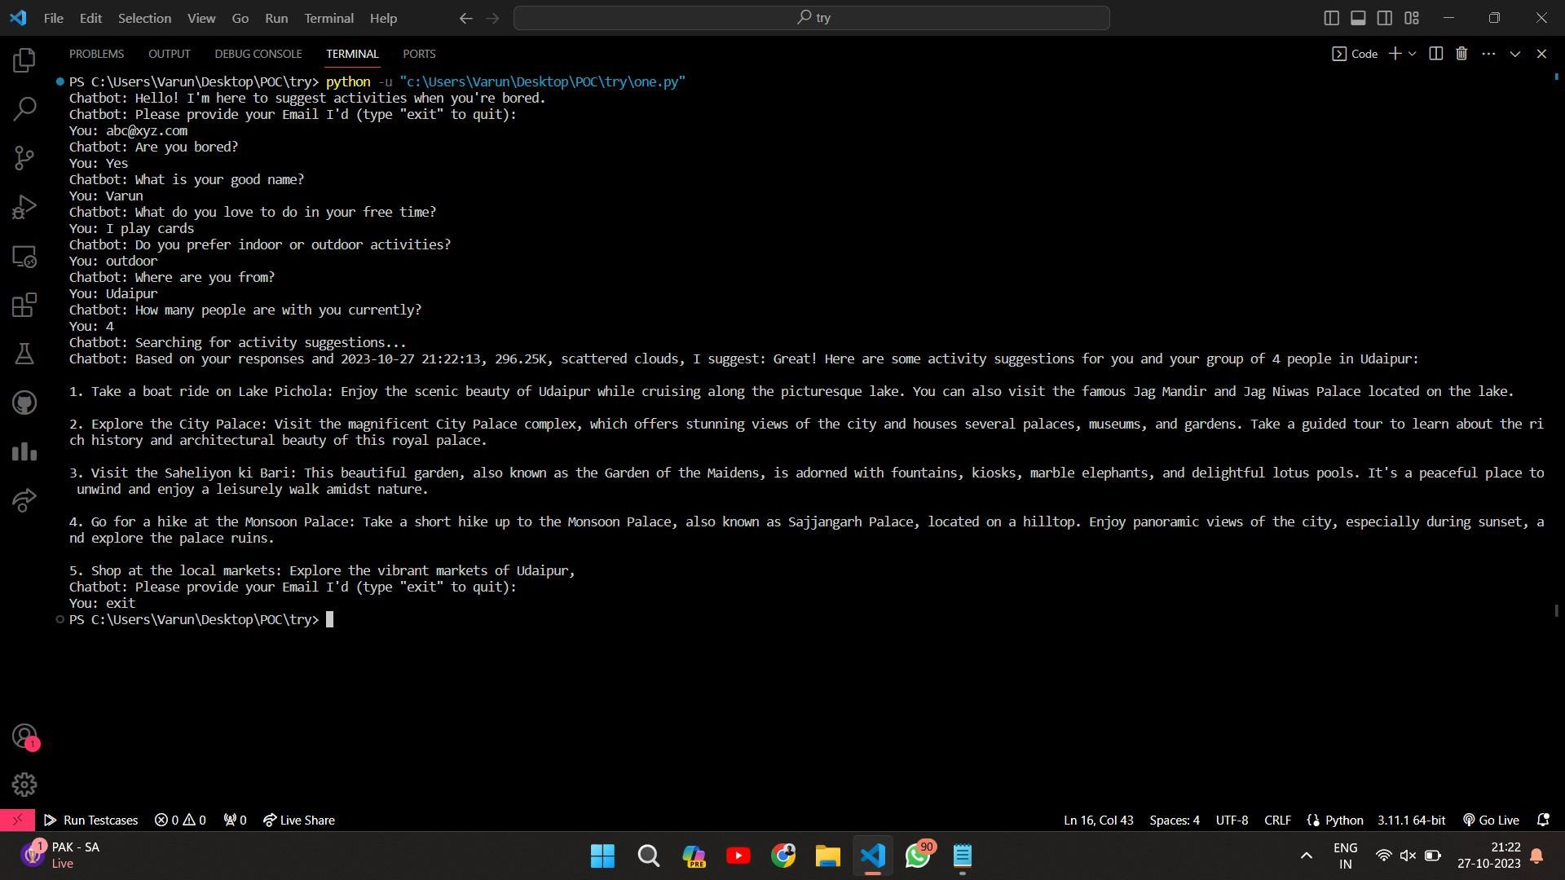

Fig 4: - Program Output

**Significance**

**Personalization:**

* The project offers personalized recommendations tailored to individual preferences, making leisure experiences more fulfilling and enjoyable.

**Integration of Factors:**

* By considering various factors such as personal preferences, location, weather, time, group size, and budget constraints, the project ensures that recommendations are relevant and suitable for each user's unique circumstances.

**Temporal Relevance:**

* The chatbot adapts recommendations based on the time of day, ensuring that activities suggested are appropriate for the moment, enhancing user satisfaction and engagement.

I**nclusivity and Accessibility:**

* Logistical considerations like group size and budget are taken into account, making leisure activities accessible to a wider range of users and promoting inclusivity.

**Variety and Novelty:**

* The project emphasizes offering diverse and novel recommendations to prevent monotony, keeping leisure experiences fresh and engaging over time.

**Paradigm Shift:**

* This project represents a significant shift in the way leisure services are delivered, moving away from traditional approaches towards a more personalized and dynamic model.

**Enrichment of Leisure Moments:**

* Ultimately, the chatbot enriches leisure moments by providing users with joyful, fulfilling, and endless opportunities for exploration, enhancing overall quality of life.

In summary, the significance of this project lies in its potential to transform leisure experiences, offering users a highly personalized and enriching concierge service that adapts to their individual preferences and enhances their enjoyment of leisure activities.

**Conclusion**

# Conclusion:

Summary of Project Objectives:

Recapitulate the primary objectives and goals of the project, emphasizing the aim to develop a personalized leisure recommendation chatbot to enhance user satisfaction and leisure experiences.

### Accomplishments and Contributions:

* Highlight the accomplishments and contributions of the project, including the successful implementation of the chatbot, integration of APIs, and development of algorithms for personalized recommendations.
* Emphasize any innovative features, techniques, or approaches employed in the project that contribute to its uniqueness and effectiveness.

### Impact on User Experience:

* Discuss the impact of the chatbot on user experience, emphasizing its ability to provide tailored leisure recommendations based on user preferences, location, and real-time weather conditions.
* Highlight the positive feedback and satisfaction expressed by users, indicating the chatbot's effectiveness in addressing user needs and enhancing leisure experiences.

### Evaluation Insights:

* Summarize the insights gained from the evaluation process, including findings from qualitative and quantitative analyses of recommendation accuracy, user satisfaction, usability, and engagement metrics.
* Discuss any notable strengths, weaknesses, or areas for improvement identified during the evaluation, providing context for future enhancements.

### Future Directions and Recommendations:

* Propose potential future directions and recommendations for the continued development and improvement of the chatbot.
* Suggest areas of focus for future iterations, such as refining recommendation algorithms, enhancing usability, expanding feature sets, and addressing user feedback.

### Implications for Leisure Industry:

* Reflect on the broader implications of the project for the leisure industry, highlighting the role of technology in enhancing leisure experiences and catering to diverse user preferences.
* Discuss the potential applications and benefits of leisure recommendation chatbots in various contexts, including tourism, entertainment, and lifestyle.

### Conclusion:

* Conclude by reaffirming the significance of the project in addressing the identified need for personalized leisure recommendations.
* Express gratitude to stakeholders, contributors, and participants who supported the project's development and evaluation.
* Emphasize the project's commitment to continuous improvement and innovation in delivering user-centric solutions for leisure enjoyment.
* By crafting a detailed conclusion, you can effectively summarize the project's achievements, insights, and implications, leaving a lasting impression of its value and significance in enhancing leisure experiences through technology.

# Advantages & Disadvantages:

## Advantages:

### Personalized Recommendations:

* Provides personalized leisure recommendations tailored to individual preferences, location, and real-time weather conditions, enhancing user satisfaction and enjoyment.

### Convenience and Accessibility:

* Offers users a convenient and accessible platform to discover leisure activities, eliminating the need for manual research and planning.

### Variety and Diversity:

* Presents a diverse range of leisure activities, including indoor and outdoor pursuits, cultural experiences, and recreational options, catering to a wide range of interests and preferences.

### Enhanced User Engagement:

* Promotes user engagement and interaction through conversational dialogue, intuitive user interface design, and relevant recommendations, encouraging continued usage and exploration.

### Efficiency and Time-saving:

* Streamlines the process of leisure activity planning by providing timely and relevant recommendations, saving users time and effort in decision-making and research.

### Weather Adaptability:

* Integrates real-time weather data to adjust recommendations based on current weather conditions, ensuring that suggested activities are suitable and enjoyable regardless of the weather.

## Disadvantages:

### Dependency on External APIs:

* Relies on external APIs for natural language processing and weather data retrieval, making the chatbot vulnerable to service disruptions, changes in API terms, or data inaccuracies.

### Privacy and Data Security Concerns:

* Raises privacy and data security concerns due to the collection and processing of user data, including location information, preferences, and interactions with the chatbot.

### Algorithmic Limitations:

* Faces challenges in accurately predicting user preferences and providing relevant recommendations due to limitations in recommendation algorithms, data quality, and user input variability.

### User Acceptance and Adoption:

* May encounter resistance or slow adoption among users who prefer traditional methods of leisure planning or are sceptical about the effectiveness of chatbot-based recommendations.

### User Experience Challenges:

* Faces usability and user experience challenges such as learning curves, language comprehension limitations, and interface design issues, which may impact user satisfaction and engagement.

### Maintenance and Updates:

* Requires ongoing maintenance and updates to address technical issues, algorithm refinements, and changes in user preferences and behaviour, ensuring the chatbot remains relevant and effective over time.

While the leisure recommendation chatbot project offers numerous advantages in enhancing leisure experiences and user satisfaction, it also faces certain challenges and limitations that need to be carefully addressed to maximize its effectiveness and user acceptance.

# Future Scope:

### Advanced Recommendation Algorithms:

* Explore advanced machine learning and artificial intelligence techniques to improve recommendation accuracy and personalization.
* Implement collaborative filtering, reinforcement learning, or hybrid recommendation approaches to enhance the chatbot's ability to understand and adapt to user preferences over time.

### Multimodal Interaction:

* Integrate multimodal interaction capabilities, including voice recognition and natural language understanding, to enable users to interact with the chatbot through speech and text.
* Incorporate visual content such as images or videos to enrich the user experience and provide additional context for leisure recommendations.

### Integration with Social Platforms:

* Integrate the chatbot with social media platforms to leverage social data and networks for more personalized and socially curated leisure recommendations.
* Enable users to share their leisure plans, experiences, and recommendations with friends and connections, fostering community engagement and collaboration.

### Geolocation-Based Services:

* Expand geolocation-based services to offer location-specific recommendations for activities, events, and attractions in different cities, regions, or countries.
* Partner with local businesses, tourism agencies, and event organizers to provide exclusive offers, discounts, and promotions to chatbot users based on their current location.

### Augmented Reality (AR) Integration:

* Incorporate augmented reality (AR) technology to enhance the visualization and immersive experience of recommended leisure activities.
* Allow users to virtually explore venues, landmarks, or cultural sites before making a decision, providing a preview of their potential leisure experiences.

### Continuous User Feedback and Learning:

* Implement mechanisms for continuous user feedback and learning to improve the chatbot's understanding of user preferences, feedback, and interactions.
* Utilize reinforcement learning techniques to adapt the chatbot's recommendations based on user feedback and reward signals, optimizing for user satisfaction and engagement.

### Cross-Platform Compatibility:

* Ensure cross-platform compatibility by developing native applications for mobile devices, smart speakers, and other emerging platforms.
* Enable seamless synchronization of user preferences and recommendations across different devices and channels, providing a consistent and personalized user experience.

### Integration with Smart Home Devices:

* Integrate the chatbot with smart home devices and virtual assistants, allowing users to access leisure recommendations through voice commands or automated routines.
* Enable users to seamlessly incorporate leisure activities into their daily routines and lifestyles, enhancing convenience and accessibility.

### Localized and Cultural Adaptation:

* Customize the chatbot's recommendations to cater to specific cultural preferences, traditions, and local interests in different regions and countries.
* Partner with local experts, cultural institutions, and tourism boards to curate culturally relevant leisure experiences and recommendations for diverse audiences.

### Ethical Considerations and Transparency:

* Address ethical considerations and privacy concerns related to data collection, user profiling, and algorithmic bias, ensuring transparency and user trust.
* Implement safeguards and controls to protect user privacy, provide opt-in/opt-out mechanisms, and offer clear explanations of how user data is used and shared.

By exploring these future directions and opportunities, the leisure recommendation chatbot project can continue to evolve and innovate, delivering enhanced user experiences, personalized recommendations, and valuable insights into leisure planning and enjoyment.

# BIBLIOGRAPHY:

* **OpenAI API: -** <https://platform.openai.com/docs/introduction>
* **Weather API:** - <https://home.openweathermap.org/api_keys>
* **Python Documentation: -** <https://docs.python.org/3/>
* **ChatGPT: -** <https://chatgpt.com/?oai-dm=1>